

|  |
| --- |
| HOSPITAL  MANAGEMENT  SYSTEM |
| Abstract  Effective hospital management integrates administrative, financial, and clinical functions to enhance patient care, improve operational efficiency, and adapt to evolving healthcare demands through strategic planning and innovative technologies.  Laptop with phone and calculator  A blue and grey text on a black background  AI-generated content may be incorrect. |
| March 12  SUNIL KUMAR PRUSTY  Sunilprusty16@gmail.com |

HOSPITAL MANAGEMENT SYSTEM

1. Description:

Hospitals are the most important part of our lives, trying to provide the best medical facilities to people suffering from various type of illness, which may be due to change in climate conditions, increased workload, emotional trauma stress etc. It is very much difficult for the hospital to maintain its day-to-day activities and records manually. That is why a database is required to keep records of all type of activities of a hospital.

Hospitals interact with a lot of people in a day and there are various activities involved in day-to-day operations of hospitals, for example managing doctor schedules, managing patient diagnoses, managing medical histories of patients, etc. The aim of this project is to show how data related to these tasks can be made easier to manage using databases.

By storing information in a relational database, all the tasks relate to daily functioning of the hospital can be performed easily and much more efficiently. Hospital Database Management System (DBMS) is a comprehensive SQL project designed to streamline and optimize the management of hospital operations. This project aims to provide an efficient and user-friendly solution for storing, retrieving, and manipulating various types of healthcare-related data.

This database contains 7 tables:

1. Physician
2. Affiliated with
3. Department
4. Nurse
5. Patient
6. Patient Diagnosis
7. Procedures

How these tables/entities are related to each other is shown on next page through ER diagram, i.e., Entity Relationship Diagram.

2.ER-Diagram (Entity Relationship Diagram) For Hospital Management System.

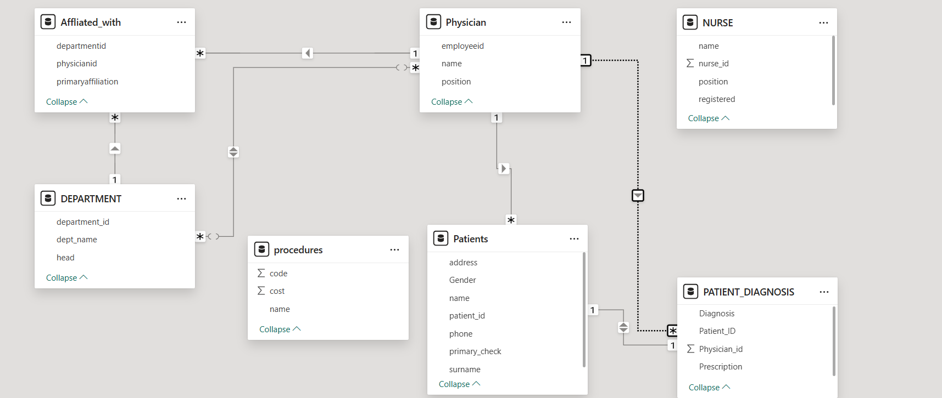

3.TABLE DESCRIPTION:

1. Physician:

|  |  |  |  |  |  |
| --- | --- | --- | --- | --- | --- |
| **Field** | **Type** | **Null** | **Key** | **Default** | **Extra** |
| Employeeid | Int | NO | PRI | NULL |  |
| Name | Varchar (150) | NO |  | NULL |  |
| Position | Varchar (150) | NO |  | NULL |  |

2.Affiliated with:

|  |  |  |  |  |  |
| --- | --- | --- | --- | --- | --- |
| **Field** | **Type** | **Null** | **Key** | **Default** | **Extra** |
| physicianid | Int | NO | MUL | NULL |  |
| departmentid | Int | NO | MUL | NULL |  |
| primaryaffiliation | varchar(1) | NO |  | NULL |  |

3.**Department:**

|  |  |  |  |  |  |
| --- | --- | --- | --- | --- | --- |
| **Field** | **Type** | **Null** | **Key** | **Default** | **Extra** |
| department_id | Int | NO | PRI | NULL |  |
| dept_name | varchar(150) | NO |  | NULL |  |
| Head | Int | NO | MUL | NULL |  |

4. Nurse:

|  |  |  |  |  |  |
| --- | --- | --- | --- | --- | --- |
| **Field** | **Type** | **Null** | **Key** | **Default** | **Extra** |
| nurse_id | Int | NO |  | NULL |  |
| Name | varchar(150) | NO |  | NULL |  |
| Position | varchar(150) | NO |  | NULL |  |
| registered | varchar(10) | NO |  | NULL |  |

5. Patient

|  |  |  |  |  |  |
| --- | --- | --- | --- | --- | --- |
| **Field** | **Type** | **Null** | **Key** | **Default** | **Extra** |
| patient_id | Int | NO | PRI | NULL | Auto increment |
| Name | varchar(100) | NO |  | NULL |  |
| Surname | varchar(100) | NO |  | NULL |  |
| Address | varchar(100) | NO |  | NULL |  |
| Gender | varchar(150) | NO |  | NULL |  |
| Phone | varchar(150) | NO |  | NULL |  |
| primary_check | Int | NO | MUL | NULL |  |

6. Patient Diagnosis:

|  |  |  |  |  |  |
| --- | --- | --- | --- | --- | --- |
| **Field** | **Type** | **Null** | **Key** | **Default** | **Extra** |
| Diagnosis | varchar(150) | NO |  | NULL |  |
| Prescription | varchar(150) | NO |  | NULL |  |
| Patient_ID | Int | NO | MUL | NULL |  |
| Physician_id | Int | NO | MUL | NULL |  |

7.Procedures:

|  |  |  |  |  |  |
| --- | --- | --- | --- | --- | --- |
| **Field** | **Type** | **Null** | **Key** | **Default** | **Extra** |
| Code | int | NO | PRI | NULL |  |
| Name | varchar(150) | NO |  | NULL |  |
| Cost | Int | NO |  | NULL |  |

4.SQL PROJECT – HOSPITAL MANAGEMENT SYSTEM BASIC QUERY.



1.Write a query in SQL to obtain the name of the physician in alphabetical order.

SELECT NAME FROM PHYSICIAN

ORDER BY NAME ASC;

TABLE OUTPUT:

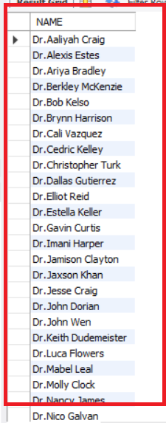

2.Write a query in SQL to obtain the full name of the patients whose gender is male.

SELECT NAME, SURNAME, CONCAT (NAME," “, SURNAME) AS FULL_NAME, GENDER

FROM PATIENT

WHERE GENDER = "MALE";

TABLE OUTPUT:

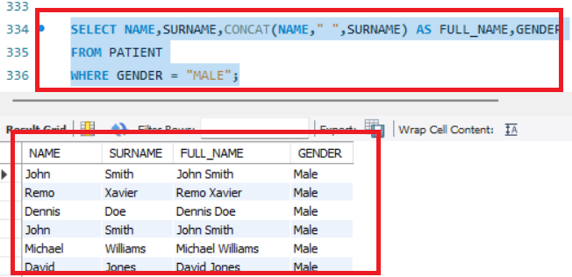

3.Write a query in SQL to find the name of the nurse who are the head of their department and are registered.

SELECT NAME,POSITION,REGISTERED

FROM NURSE

WHERE POSITION = "Head Nurse" AND REGISTERED = "YES";

TABLE OUTPUT:

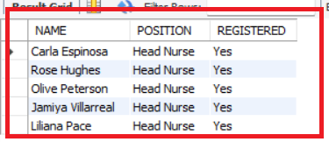

4.Write a query in SQL to find the name of the nurse who are Team Leader or not registered.

SELECT NAME,POSITION,REGISTERED

FROM NURSE

WHERE POSITION = "Head Nurse" AND REGISTERED = "No";

TABLE OUTPUT:

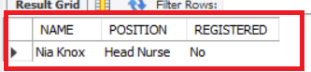

5.Write a query to obtain the average cost of all the medical procedures.

SELECT AVG(COST) AS AVG_COST

FROM PROCEDURES;

TABLE OUTPUT:

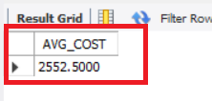

6.Write a query to obtain name and cost of the procedure whose cost is greater than 2000.

SELECT NAME,COST

FROM PROCEDURES

WHERE COST >2000;

TABLE OUTPUT:

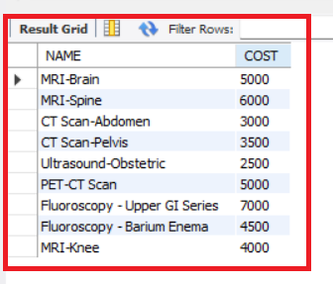

7.Write a query to update the name of the patient to Robert Fernandez having patient id as 5.

UPDATE PATIENT

SET NAME = "Robert",SURNAME = "Fernandez"

WHERE PATIENT_ID = 5;

SELECT * FROM PATIENT WHERE PATIENT_ID = 5;

TABLE OUTPUT:

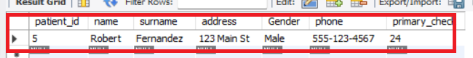

8.Write a query to drop phone column from patient table.

ALTER TABLE PATIENT

DROP COLUMN PHONE;

SELECT * FROM PATIENT;

TABLE OUTPUT:

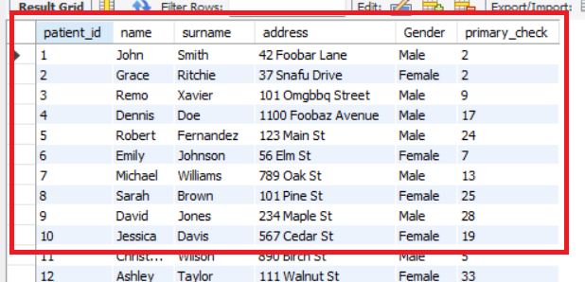

9.Write a query to find second maximum cost of medical procedure?

#1ST_WAY

WITH SECOND_HIGHEST_COST AS

(SELECT CODE,NAME,COST,

DENSE_RANK() OVER(ORDER BY COST DESC) AS RANKING

FROM PROCEDURES)

SELECT * FROM SECOND_HIGHEST_COST WHERE RANKING =2;

TABLE OUTPUT:

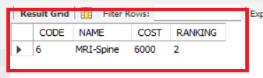

# 2ND WAY

SELECT MAX(COST) AS SECOND_HIGHEST_COST

FROM PROCEDURES

WHERE COST < (SELECT MAX(COST) FROM PROCEDURES);

TABLE OUTPUT:



10.Write a query in SQL to obtain the name of the patients starting with letter A.

SELECT CONCAT(NAME," ",SURNAME) AS FULL_NAME,GENDER

FROM PATIENT

WHERE CONCAT(NAME," ",SURNAME) LIKE 'A%';

TABLE OUTPUT:

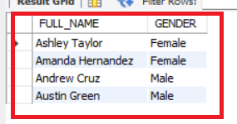

11. Write a query in SQL to obtain the name of the patients whose third letter is M.

SELECT *

FROM PATIENT

WHERE SUBSTRING(NAME,3,1) = 'M';

SELECT CONCAT(NAME," ",SURNAME) AS FULL_NAME

FROM PATIENT

WHERE CONCAT(NAME," ",SURNAME) LIKE '__M%';

TABLE OUTPUT:

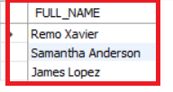

12.Write a query in SQL to obtain the name of the patients whose name start with letter J and ends with Z.

SELECT CONCAT(NAME," ",SURNAME) AS FULL_NAME

FROM PATIENT

WHERE CONCAT(NAME," ",SURNAME) LIKE 'J%Z';

TABLE OUTPUT:

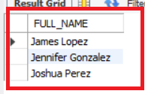

13. Write a query to obtain patient details having patient id 11 to 20.

SELECT *

FROM PATIENT

WHERE PATIENT_ID BETWEEN 11 AND 20;

TABLE OUTPUT:

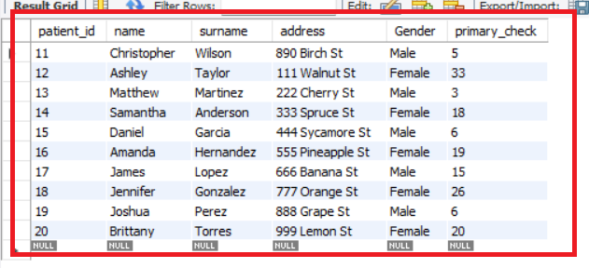

14.Write a query in SQL to obtain the name of the physicians who are the head of each department.

HOSPITAL MANAGEMENT SYSTEM OF ADVANCE QUERY.

SELECT P.NAME AS DOCTORS_NAME,D.DEPT_NAME

FROM PHYSICIAN P

INNER JOIN DEPARTMENT D

ON P.EMPLOYEEID = D.HEAD;

TABLE OUTPUT:

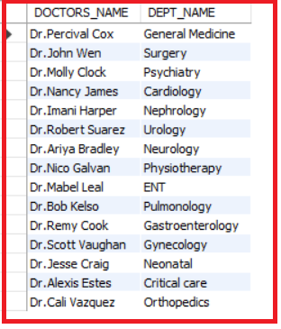

15. Write a query in SQL to obtain the name of the patients with their physicians by whom they got their preliminary treatment

SELECT CONCAT(P.NAME," ",P.SURNAME) AS PATIENT_NAME,PH.NAME AS PHY_WHO_DID_PRELIMINARY_TRE

FROM PATIENT P

LEFT JOIN PHYSICIAN PH

ON P.PRIMARY_CHECK = PH.EMPLOYEEID;

TABLE OUTPUT:

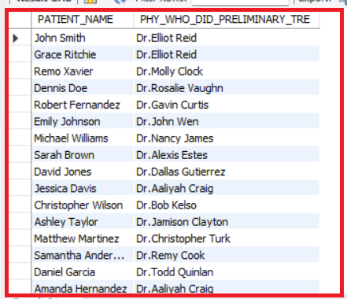

16.Write a query in SQL to obtain the name of the physician with the department who are done with affiliation.

SELECT

PH.NAME AS DOCTOR_NAME,

D.DEPT_NAME

FROM PHYSICIAN PH

INNER JOIN DEPARTMENT D

ON PH.EMPLOYEEID = D.HEAD

INNER JOIN AFFILIATED_WITH A ON PH.EMPLOYEEID = A.PHYSICIANID

WHERE A.PRIMARYAFFILIATION = 'T';

TABLE OUTPUT:

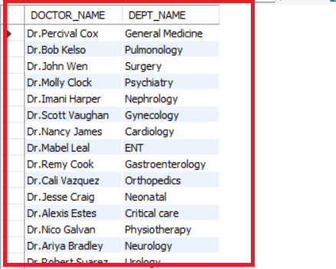

17.Write a query to obtain physician name, position and department they are affiliated with.

SELECT

PH.NAME AS DOCTOR_NAME,

PH.POSITION,

D.DEPT_NAME

FROM PHYSICIAN PH

INNER JOIN AFFILIATED_WITH A

ON PH.EMPLOYEEID = A.PHYSICIANID

INNER JOIN DEPARTMENT D

ON A.DEPARTMENTID = D.DEPARTMENT_ID;

TABLE OUTPUT:

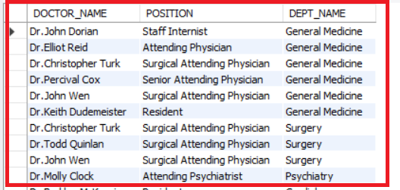

18.Write a query in SQL to obtain the patient name from which physician they get primary checkup and also mention the patient diagnosis with prescription.

SELECT CONCAT(P.NAME," ",P.SURNAME) AS Patient_Name,

P.GENDER,

PH.NAME AS Doctor_Name,

PH.POSITION,

PD.DIAGNOSIS AS Patient_Diagnosis,

PD.PRESCRIPTION AS Patient_Prescription

FROM PATIENT_DIAGNOSIS PD

LEFT JOIN PHYSICIAN PH

ON PD.PHYSICIAN_ID = PH.EMPLOYEEID

LEFT JOIN PATIENT P

ON P.PATIENT_ID = PD.PATIENT_ID;

TABLE OUTPUT:

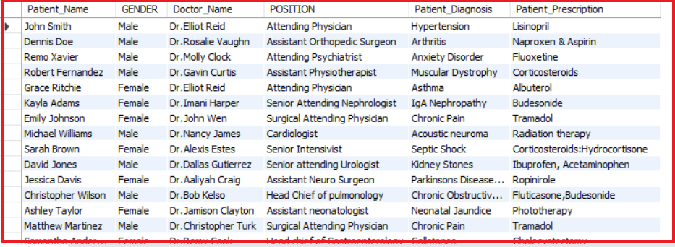



Hospital Management System Advance Query (Subquery)

19. Write a query in SQL to obtain the maximum cost of the medical procedure.

SELECT NAME,COST FROM PROCEDURES

WHERE COST = (SELECT MAX(COST) FROM PROCEDURES);

TABLE OUTPUT:

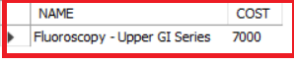

20. Write a query in SQL to obtain the details of patient who has diagnosed with chronic pain.

SELECT * FROM PATIENT

WHERE PATIENT_ID IN (SELECT PATIENT_ID FROM PATIENT_DIAGNOSIS WHERE DIAGNOSIS = 'Chronic Pain');

TABLE OUTPUT:

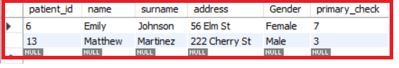

21. Write a query in SQL to obtain the procedure name and cost whose cost is greater than the average cost of all the procedure.

SELECT NAME,COST

FROM PROCEDURES

WHERE COST > (SELECT AVG(COST) FROM PROCEDURES);

TABLE OUTPUT:

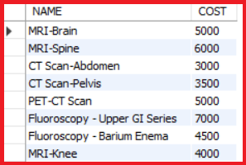

22. Write a query in SQL to obtain the procedure name and cost whose cost is less than the average cost of all the procedure.

SELECT NAME,COST

FROM PROCEDURES

WHERE COST < (SELECT AVG(COST) FROM PROCEDURES);

TABLE OUTPUT:

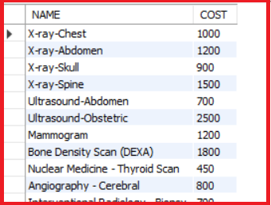

23. Write a query in SQL to obtain the physician name who are either head chief or senior in their respective department.

SELECT * FROM PHYSICIAN

WHERE POSITION IN

(SELECT POSITION

FROM PHYSICIAN

WHERE POSITION LIKE '%HEAD CHIEF%' OR POSITION LIKE '%SENIOR%');

TABLE OUTPUT:

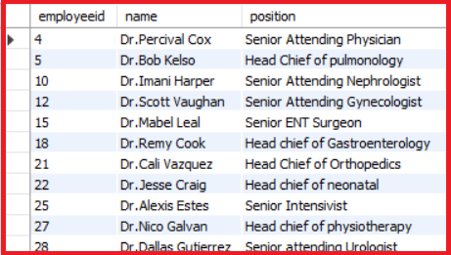

24. Write a query in SQL to obtain the employee id, physician name and position whose primary affiliation has not been done.

SELECT * FROM PHYSICIAN

WHERE EMPLOYEEID IN (SELECT PHYSICIANID FROM AFFILIATED_WITH WHERE PRIMARYAFFILIATION = 'f');

TABLE OUTPUT:

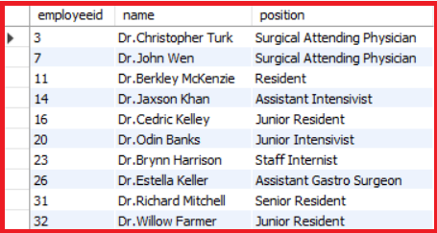



THANK YOU